QUIDs -Tullamore’s Shopping Voucher

Retailers Pack 2023
QUIDs is a shopping voucher scheme operated by Tullamore Credit Union and Tullamore & District Chamber of Commerce since 2008.
This note provides information to retailers on the QUIDs Tullamore Shopping Voucher.
Full details can be found on the web-site.

Web-site
Details on how to buy, how to redeem etc. can be found on the web-page; www.tullamorechamber.com/what-we-do/tullamore-voucher-scheme

Accepting QUIDs in your Outlet
- No special registration is required. Please inform the Chamber of Commerce office (info@tullamorechamber.com) to be included on the list of outlets currently accepting vouchers.
- Please ensure you are familiar with the first and second and third generation of QUIDs and their security features (see following pages).
- Expiry Dates. The Vouchers are open-ended. The date of issue is stamped on the reverse. A 12-month life is noted on reverse of 1st and 2nd generation QUIDs to encourage spending. QUIDs with any issue date should be accepted and there will be no difficulty with redemption at Tullamore Credit Union (TCU).
- QUIDS are printed in €100, €50, €20, €10 and €5 values. The €100 QUID was new in 2022. Details of all are found below.

Redemption of QUIDs
- Any amount of QUIDs received in your business can be exchanged for a cheque to your business at the TCU cash-desks in Patrick St. If not known to the TCU, it may be useful to bring a letter head or some item that confirms your business name.

Sales (How to Purchase)
The voucher scheme is primarily a business-to-business scheme created when the Revenue introduced the Small Benefit Exemption Scheme which allows employers to give vouchers to employees to a maximum of €1000 tax-free. Vouchers largely sold to business, a small amount are sold directly to the public.

Corporate Sales
Businesses can only purchase QUIDs from Tullamore Chamber of Commerce. To arrange a purchase please email info@tullamorechamber.com

General Sale

Marketing & Promotion
- Tullamore Chamber of Commerce promotes the scheme primarily for corporate purchases as there are significant tax benefits to using QUIDs as a staff reward.
- Tullamore Credit Union and Tullamore Chamber promote the scheme to the public.
- The scheme will be promoted through print and social media and direct to business.
- Make sure your business is included on the web-site (email us).
- Images are available for social media (email us).

Again, further information on where to buy or how to use QUIDs can be found at www.tullamorechamber.com/what-we-do/tullamore-voucher-scheme

For queries etc. please contact Tullamore Chamber of Commerce on 057-9323698 or email info@tullamorechamber.com

QUIDS 3rd Generation - 2022 Issue
A €100 QUID voucher is being introduced to the already available €50, €20, €10 and €5 vouchers. The new voucher is in a similar style to the €50 and €20 vouchers. They include the same security features; holographic strip, unique serial number and quality card print. These features are described in the following pages.

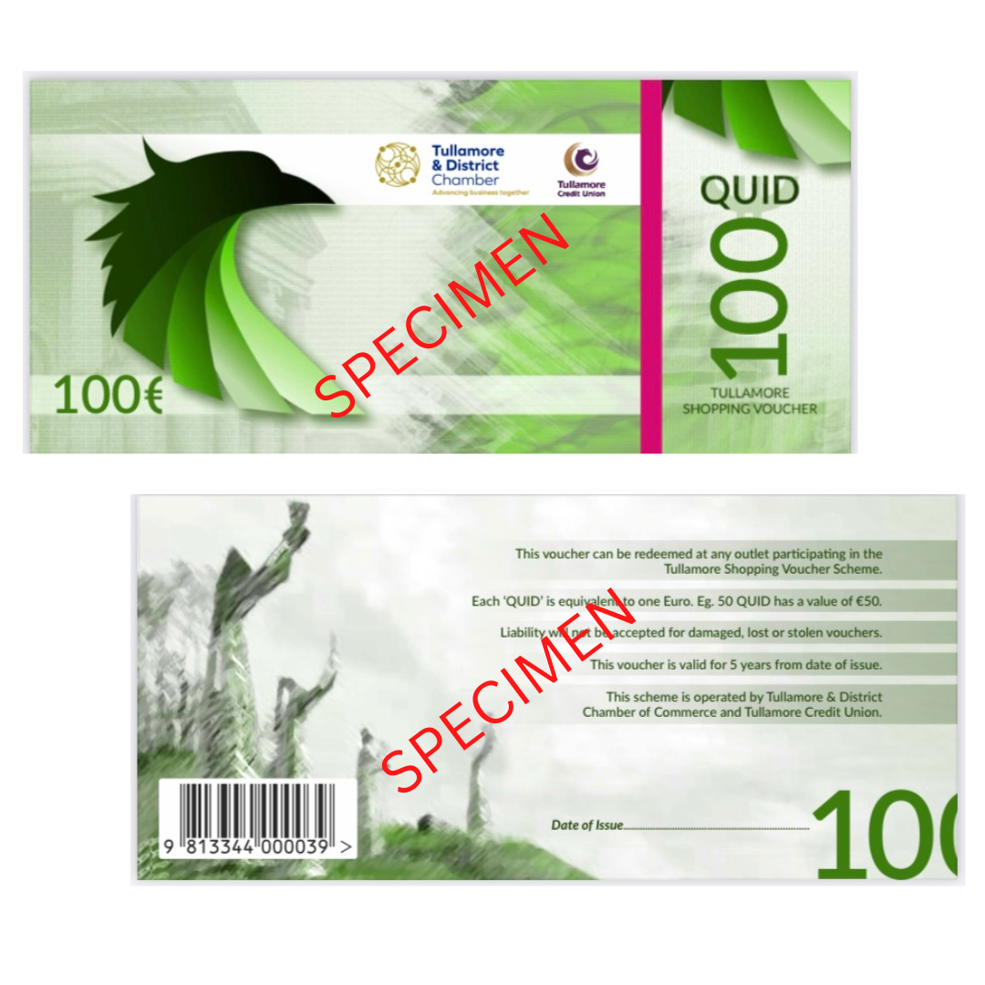

QUIDS 2nd Generation - 2015 Issue
A new design of the QUIDs Tullamore Shopping Voucher is being issued during November 2016.
The new QUID voucher is available only in €50 and €20 denominations.
The older style QUIDs available in €50, €20, €10 and €5 denominations remain valid, please continue to accept the older style design.
The front and rear of the new QUID vouchers are illustrated below and features are described overleaf.
Later issues of the €50 and €20 include a bar-code on the reverse.
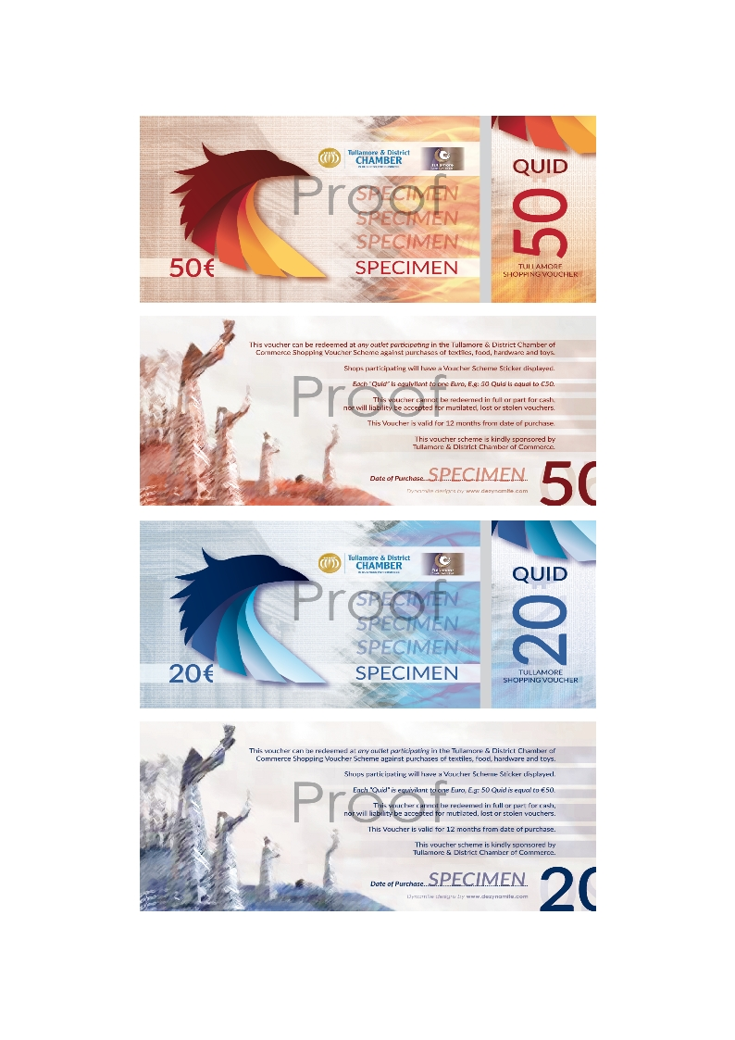

New Issue QUID features
The features of the new QUID shopping vouchers are illustrated below.
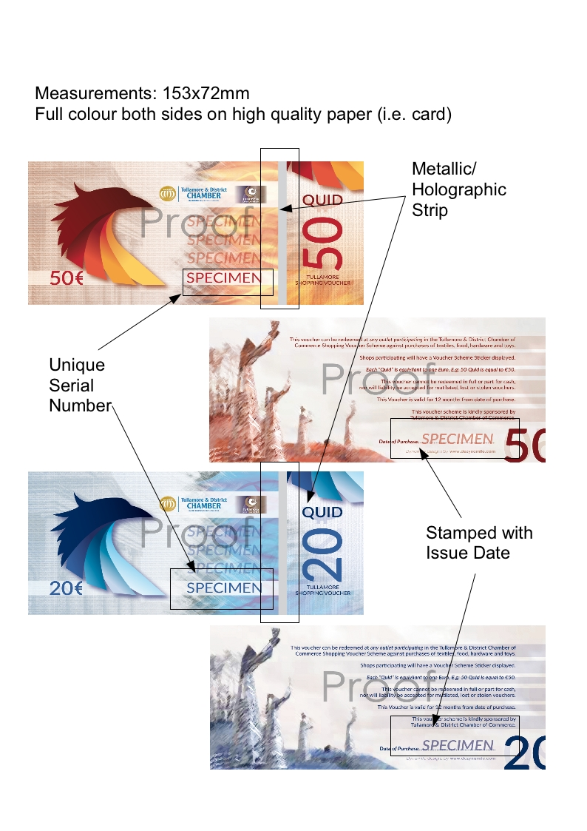
For further information please contact Tullamore & District Chamber of Commerce 057-9323698 or email info@tullamorechamber.com.

QUIDS 1st Generation - 2008 Issue
